Cross-quantilogram: GBPUSD and USDJPY
Method 20 / daily log returns / expanding quantiles / Alpari D1 full available history

Study setup
Logical pair: GBPUSD , USDJPY
Broker symbols: GBPUSD_i , USDJPY_i
Snapshot: 2026-11-03_majors_alpari_D1
Timeframe: D1
Matched return window: 1999-01-05 to 2026-11-02 (UTC bar dates)
Matched return count n: 7200
Dropped unfinished last bar dated 2026-11-03 UTC after a tick-volume check against the prior complete day.
Quantiles: expanding window, min history 252 days
tau in [0.05, 0.2]; k=0..10; headline tau=0.05, k=1
Complete matched rows (Excel): GBPUSD-USDJPY_CQ_D1.xlsx
Complete matched rows (HTML table): GBPUSD-USDJPY_CQ_D1_data.html

Method carried forward
The cross-quantilogram rho_tau(k) measures linkage among centered quantile-hit indicators of matched daily log returns of close, ln(close_t / close_t-1). Quotes are not inverted. At each date t, the tau-quantile uses only returns through t (expanding window) after a minimum history of 252 days. Hits are h_t = 1(r_t < q_t) - tau. rho_tau(k) is the normalized cross-product of h_x,t with h_y,t+k. Levels tau in {0.05, 0.20} and lags k=0..10 are pre-specified; headline is tau=0.05, k=1 both directions. Same-sample Pearson r is a side check. This is not causation and not a trading signal.

Results (headline)
rho_GBPUSD->USDJPY(tau=0.05,k=1): 0.030509
rho_USDJPY->GBPUSD(tau=0.05,k=1): 0.043328
rho_GBPUSD->USDJPY(tau=0.20,k=1): 0.031565
rho_USDJPY->GBPUSD(tau=0.20,k=1): 0.030617
Pearson r: -0.198556

CQ table (tau=0.05)
k | rho_GBPUSD_to_USDJPY | n_GBPUSD_to_USDJPY | rho_USDJPY_to_GBPUSD | n_USDJPY_to_GBPUSD
0 | 0.03692606 | 6949 | 0.03692606 | 6949
1 | 0.03050891 | 6948 | 0.04332778 | 6948
2 | 0.01768217 | 6947 | 0.04011537 | 6947
3 | 0.03690291 | 6946 | 0.04331245 | 6946
4 | 0.02087123 | 6945 | 0.01766643 | 6945
5 | 0.05291159 | 6944 | 0.0400923 | 6944
6 | 0.00803615 | 6943 | 0.011241 | 6943
7 | 0.04007692 | 6942 | 0.04007692 | 6942
8 | 0.01443005 | 6941 | 0.05288882 | 6941
9 | 0.02403693 | 6940 | 0.02724185 | 6940
10 | 0.03043901 | 6939 | 0.03364395 | 6939

Conclusion
Headline tau=0.05, k=1 for GBPUSD and USDJPY: rho_GBPUSD->USDJPY = 0.0305; rho_USDJPY->GBPUSD = 0.0433. At tau=0.20, k=1: 0.0316 and 0.0306. Same-day tau=0.05 rho(k=0) = 0.0369. Pearson r = -0.1986. This is quantile-hit linkage, not a trading signal.

Charts
Daily closes

Daily log returns

Cross-quantilogram tau=0.05
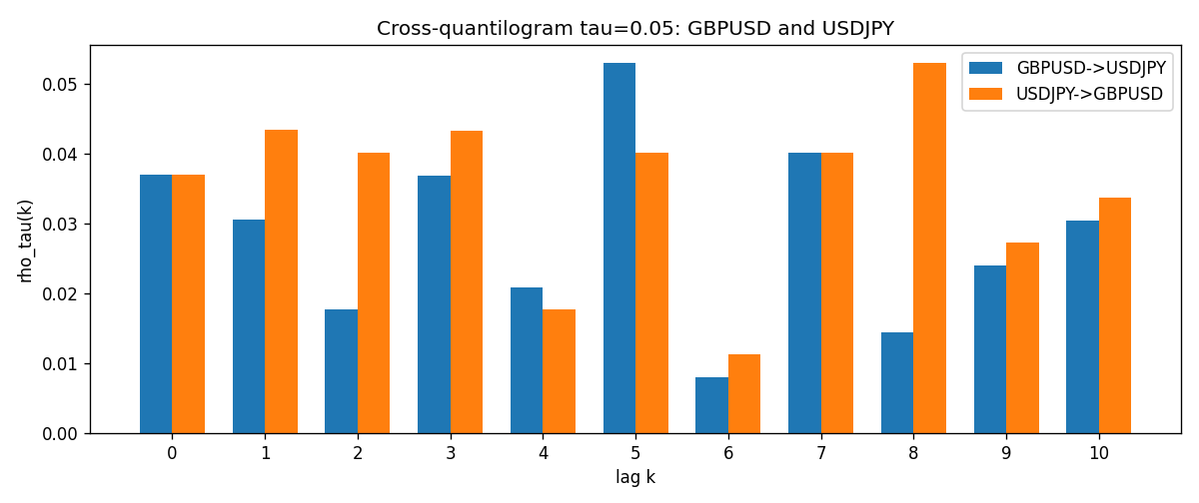

Data report
Matched rows and the CQ sheet are in the sibling Excel workbook named GBPUSD-USDJPY_CQ_D1.xlsx. Embedding all rows as a Word table is impractical; this file holds column summaries and the first and last 15 matched rows.
Columns: time, GBPUSD_open, USDJPY_open, GBPUSD_high, USDJPY_high, GBPUSD_low, USDJPY_low, GBPUSD_close, USDJPY_close, GBPUSD_tick_volume, USDJPY_tick_volume, GBPUSD_spread, USDJPY_spread, GBPUSD_real_volume, USDJPY_real_volume, GBPUSD_log_return, USDJPY_log_return, GBPUSD_h_t005, USDJPY_h_t005
Column summaries (matched calculation rows)
column | count | mean | std | min | 25% | 50% | 75% | max
GBPUSD_open | 7200 | 1.5159933 | 0.21821503 | 1.06854 | 1.3249725 | 1.51133 | 1.63163 | 2.1066
USDJPY_open | 7200 | 113.81122 | 19.205564 | 75.693 | 104.42925 | 110.991 | 120.69125 | 163.824
GBPUSD_high | 7200 | 1.5222906 | 0.21878569 | 1.08366 | 1.329785 | 1.518035 | 1.638315 | 2.1161
USDJPY_high | 7200 | 114.30876 | 19.267108 | 76.001 | 104.8815 | 111.4435 | 121.26 | 163.978
GBPUSD_low | 7200 | 1.5096683 | 0.2174426 | 1.03518 | 1.319445 | 1.50319 | 1.6243 | 2.0983
USDJPY_low | 7200 | 113.28793 | 19.133561 | 75.402 | 103.89 | 110.5305 | 120.17 | 163.628
GBPUSD_close | 7200 | 1.5160611 | 0.21817876 | 1.06879 | 1.3250775 | 1.511235 | 1.63193 | 2.1065
USDJPY_close | 7200 | 113.82409 | 19.220954 | 75.811 | 104.42 | 111.028 | 120.6855 | 163.851
GBPUSD_tick_volume | 7200 | 94838.03 | 153554.65 | 62 | 10001.75 | 52905.5 | 91812.25 | 1273370
USDJPY_tick_volume | 7200 | 106136.9 | 179308.31 | 149 | 9925 | 53095 | 92761 | 1803508
GBPUSD_spread | 7200 | 26.967917 | 19.192953 | 0 | 11 | 20 | 50 | 50
USDJPY_spread | 7200 | 20.325556 | 17.633971 | 0 | 6 | 11 | 30 | 50
GBPUSD_real_volume | 7200 | 3.5565837e+09 | 8.4444068e+10 | 0 | 0 | 0 | 0 | 2.4038164e+12
USDJPY_real_volume | 7200 | 3.470121e+10 | 1.6077679e+11 | 0 | 0 | 0 | 0 | 3.8834203e+12
GBPUSD_log_return | 7200 | -2.396e-05 | 0.00564572 | -0.08388241 | -0.0031301 | 3.232e-05 | 0.00317911 | 0.03112653
USDJPY_log_return | 7200 | 4.769e-05 | 0.00620489 | -0.03908203 | -0.00320192 | 0.00011421 | 0.00340709 | 0.05184024
GBPUSD_h_t005 | 6949 | 0.00123039 | 0.22048319 | -0.05 | -0.05 | -0.05 | -0.05 | 0.95
USDJPY_h_t005 | 6949 | -0.00668442 | 0.20358121 | -0.05 | -0.05 | -0.05 | -0.05 | 0.95
First 15 matched rows (selected columns)
time | GBPUSD_log_return | USDJPY_log_return | GBPUSD_h_t005 | USDJPY_h_t005
1999-01-05 | -0.0028966287 | -0.00017868311 | nan | nan
1999-01-06 | -0.00060452184 | 0.0075660159 | nan | nan
1999-01-07 | -0.002118709 | -0.012851583 | nan | nan
1999-01-08 | -0.0058954193 | -0.0047719894 | nan | nan
1999-01-11 | -0.0056851331 | -0.016195423 | nan | nan
1999-01-12 | 0.0022657001 | 0.032310364 | nan | nan
1999-01-13 | 0.0091330396 | 0.0081373171 | nan | nan
1999-01-14 | 0.0019376331 | 0 | nan | nan
1999-01-15 | -0.0017558204 | 0.0055343401 | nan | nan
1999-01-18 | 0.0012112405 | 8.7600193e-05 | nan | nan
1999-01-19 | 0.0018745281 | -0.0056219403 | nan | nan
1999-01-20 | -0.0049053846 | -0.0053879917 | nan | nan
1999-01-21 | 0.0031518998 | 0.0084664056 | nan | nan
1999-01-22 | 0.0024781662 | 0.0060412564 | nan | nan
1999-01-25 | 0.0012066366 | -0.0073594164 | nan | nan
Last 15 matched rows (selected columns)
time | GBPUSD_log_return | USDJPY_log_return | GBPUSD_h_t005 | USDJPY_h_t005
2026-10-13 | 0.0036434319 | -0.0018932826 | -0.05 | -0.05
2026-10-14 | -0.0049164679 | 7.5800166e-05 | -0.05 | -0.05
2026-10-15 | 0.0065976411 | -0.0018524319 | -0.05 | -0.05
2026-10-16 | 0.0037592051 | -0.00037976126 | -0.05 | -0.05
2026-10-19 | -0.0017500314 | 0.0034946841 | -0.05 | -0.05
2026-10-20 | 0.0055923442 | -0.0022546642 | -0.05 | -0.05
2026-10-21 | 0.0012476328 | -0.00032883504 | -0.05 | -0.05
2026-10-22 | 0.00022396082 | -0.0085942669 | -0.05 | -0.05
2026-10-23 | -0.0021146949 | 0.00035080446 | -0.05 | -0.05
2026-10-26 | -0.0024340661 | 0.0041238746 | -0.05 | -0.05
2026-10-27 | -0.0023648393 | 0.0027651658 | -0.05 | -0.05
2026-10-28 | 0.0015771808 | -0.00095679538 | -0.05 | -0.05
2026-10-29 | 0.0035881935 | -0.00038043789 | -0.05 | -0.05
2026-10-30 | 0.0013450605 | -0.0010596481 | -0.05 | -0.05
2026-11-02 | 0.0010971256 | 0.0026438521 | -0.05 | -0.05

